The Copywriter’s Thesaurus: Write Words That Sell

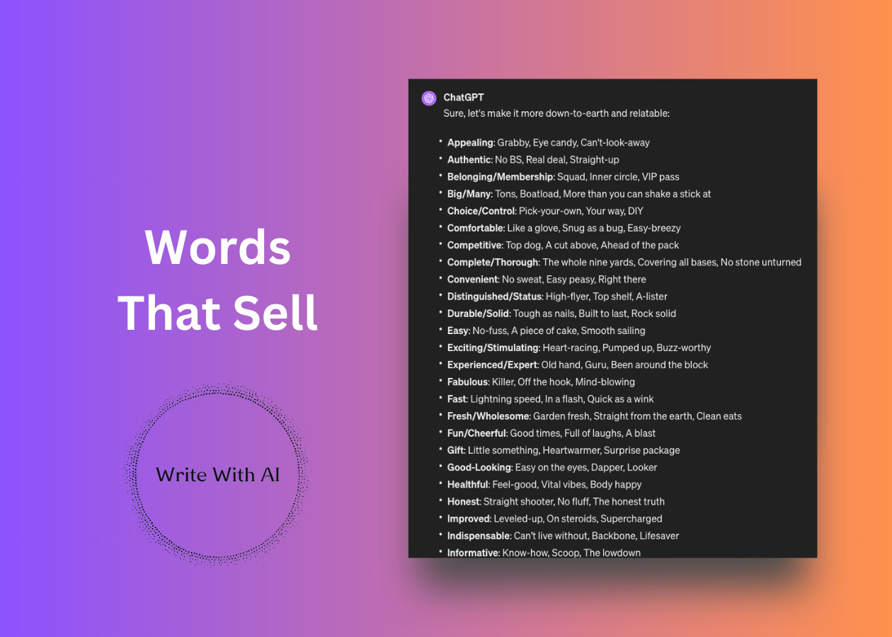

Ahoy, Digital Writers!
In 2006, author Richard Banyan compiled a massive list of 6,000 words and phrases that sell.
And when it comes to writing words that grab attention, there is no substitute for his book with the same promise: Words That Sell. The book has more than 75 lists designed to help you find the words and phrases that win over readers in your hooks, headlines, sales copy, social posts, newsletters, etc.
Why fill your writing with everyday words when you can stir up emotions and visual imagery in the hearts and minds of your readers?
The Copywriter’s Thesaurus
As in any standard thesaurus, Words That Sell is organized by topic.
Look up “Stylish,” for example, and you’ll find terms like elegant and smashing. Under “Convenient” you’ll encounter easily accessible and take it anywhere. But this book departs from the usual thesaurus in one major way.
It’s organized by the progression of writing from beginning to end:
- From hooks that get attention
- To descriptions and benefits that create appeal
- And finally to closers to win over your reader
It’s the perfect book to keep handy on your desk for anytime you sit down to write.
But here’s the thing:
ChatGPT is a good copywriter’s thesaurus too. And it’s an even better solution for when you need a bunch of words to help you find the right way to communicate your message.
So if you’re tired of relying on the same old phrases that everyone else uses (including ChatGPT’s famous "Game-changer") and you want to avoid making people’s eyes glaze over, you’ll like today’s prompts.
Train ChatGPT To Write Words That Sell
Below you will find 5 different ChatGPT prompts to help you brainstorm different words to use in your writing.
- Hooks
- Benefits
- Closers
- Emotions
- Outcomes
Each prompt is designed to give you a starter set of 3 “Words That Sell” for each category in the list to get your creativity flowing.
The best way to use these prompts is to first think about what you’re trying to say, then choose the prompt to help you say it. For example, if you want to convey the benefit of “big,” for example, go to the prompt “Benefits.” Or if you’re looking for an intriguing question to lead off your copy, try the “Hooks” prompt and look for “Opening with a Question.”
Once you find a category, run the ChatGPT prompt to brainstorm words.
Then drill down into different categories and ask ChatGPT for more words and phrases for that category. For example, “Hey ChatGPT, can you give me 10 more Teasers?”
Here’s another tip:
You can also change the tone and style to get a different variety of words. To do this, you can add a command like “Use an informal, colloquial tone” to keep it informal or “Use a business professional tone” for a more polished tone.
The words and phrases under each topic aren’t necessarily synonyms. They’re simply useful expressions gathered in one place to help you express the idea you have in mind with a higher “voltage.”
It's time for the prompts.
No input is necessary to run these scripts. After you run the initial prompt, ask ChatGPT for more or change the tone. Then, find a word that works and add it to your writing. Easy.
Let's go.
1. Hooks
Sprinkle these in your hooks, headlines, and sentence openers to grab attention:
I am going to give you a list of types of attention-getters that pull an audience into a message.

I want you to give me a list 3 words or phrases for each category of "Words That Sell."

For example, for the category "Teasers" you might give me Win, Save, Get, Free, Free trial, Inside, etc.

Attention-Getter Categories =

- Teasers
- Free/Prize
- Sale/Discount
- Trial Offer/No Obligation
- Heads and Slogans
- Salutations and Invitations
- Opening with a Question
- Opening with a Statement
- Opening with a Challenge
- Snappy Transitions
2. Benefits
Use these to describe the quality of your product/service for the reader:
I am going to give you a list of types of words and phrases used to convey the compelling qualities of your product or service

I want you to give me a list 3 words or phrases for each category of "Words That Sell."

For example, for the category "Appealing" you might give me irresistible, special, delightful, wonderful, marvelous, enchanting, magical, charming, etc.

Quality Categories =

- Appealing
- Authentic
- Belonging/Membership
- Big/Many
- Choice/Control
- Comfortable
- Competitive
- Complete/Thorough
- Convenient
- Distinguished/Status
- Durable/Solid
- Easy
- Exciting/Stimulating
- Experienced/Expert
- Fabulous
- Fast
- Fresh/Wholesome
- Fun/Cheerful
- Gift
- Good-Looking
- Healthful
- Honest
- Improved
- Indispensable
- Informative
- Luxurious
- Made
- Money-Making
- Money-Saving
- New/Advanced
- Plain/Natural
- Pleasure/Satisfaction
- Popular
- Powerful
- Reliable
- Results/Performance
- Romantic
- Security/Peace of Mind
- Self-Improvement
- Sensory Qualities
- Service/Help
- Sexy
- Small/Less
- Sophisticated/Smart
- Stylish
- Suitable
- Superior
- Timely
- Traditional/Classic
- Unusual
- Useful/Practical
- Valuable

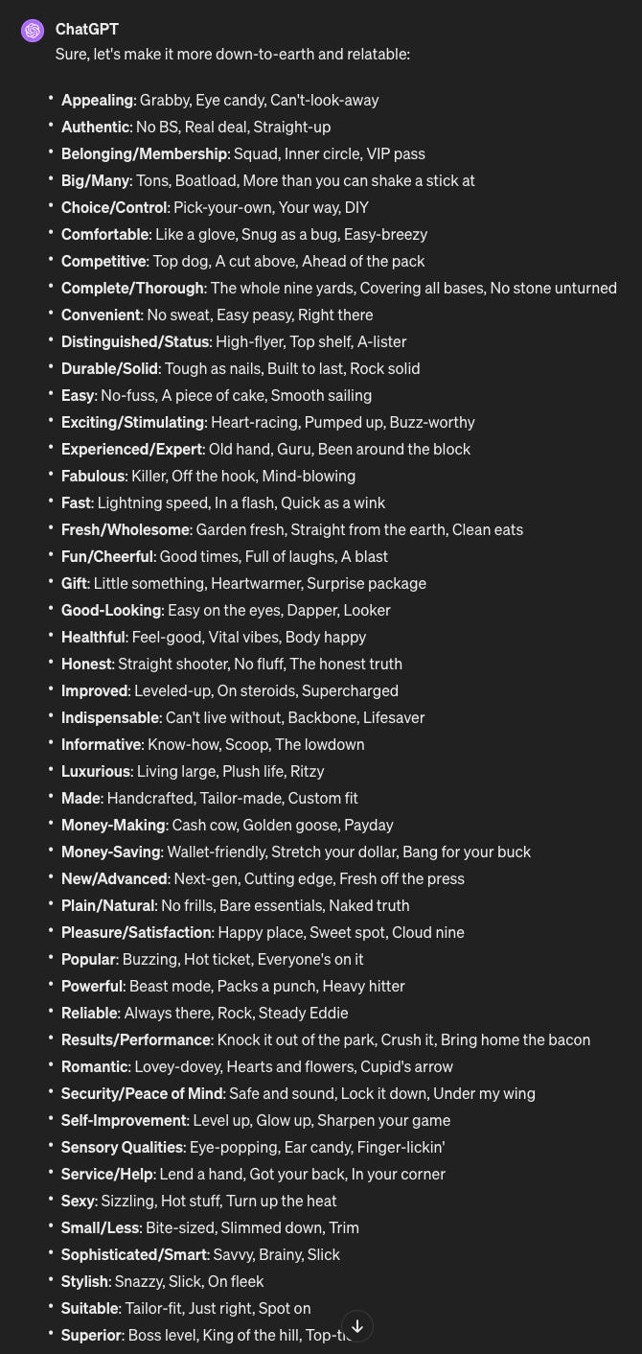

3. Closers
Use these to push an undecided reader to respond and move them to action:
I am going to give you a list of types of words and phrases used as persuasive closing statements (including guarantees and ordering information) that can push an undecided reader over the response threshold.

I want you to give me a list 3 words or phrases for each category of "Words That Sell."

For example, for the category "Persuading Your Audience" you might give me "Without a doubt", "In short, this _____ will help you", "You get all these benefits:", "Start reaping the benefits today.", "It’s a small investment that will deliver tremendous benefits." etc.

Closing Categories =

- Persuading Your Audience
- Minimizing Risk
- The Moment of Decision
- The Call to Action
- The P.S.
- The Lift Note
- Guarantees
- Order Information
- Following Through
4. Emotions
Connect with your reader on an emotional level with any of these triggers:
I am going to give you a list of types of words and phrases used as emotional triggers.

I want you to give me a list 3 words or phrases for each category of "Words That Sell."

For example, for the category "Annoyance" you might give me "Fed up","Limited", "Grinding your gears", "Inefficient", etc.

Emotion Categories =

- Annoyance
- Benevolence
- Boredom
- Complacence
- Confidence
- Confusion
- Curiosity
- Desperation
- Disgust
- Embarrassment
- Envy
- Exhaustion
- Fear
- Guilt
- Happiness
- Indifference
- Insecurity
- Laziness
- Loneliness
- Love
- Lust
- Optimism
- Passion
- Patriotism
- Pessimism
- Pride
- Revenge
- Sadness
- Shyness
- Stupidity
- Surprise
- Sympathy
- Vanity
- Whimsy
- Wit

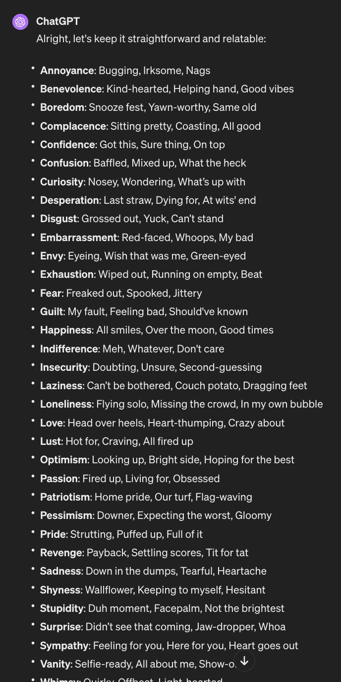

5. Outcomes
The reader is reading for 1 reason—to get an outcome. Use these words to help them see your offer with a fresh perspective:
I am going to give you a list of types of words and phrases used as outcomes/transformation triggers.

I want you to give me a list 3 words or phrases for each category of "Words That Sell."

For example, for the category "Cut Time" you might give me "Quick","Fast", etc.

Outcome/Transformation Categories =

- Cut Time
- Get more of a positive result
- Reduce an existing negative result
- Make a task easier
- Get started with something new
- Save time
- Do something
- Get somewhere faster
- Save energy
- Feel better about themselves
- Avoid a negative result now
- Avoid a negative result in the future
- Get started in something difficult/complicated
- Save money
- Make money
That’s it!

